**What is Sharding in SQL?**

The process of breaking up large tables into smaller chunks (called shards) that are spread across multiple servers is called Sharding.   
The advantage of Sharding is that since the sharded database is generally much smaller than the original; queries, maintenance, and all other tasks are much faster.

INSERT INTO table_name (column1, column2, column3,...)

VALUES (value1, value2, value3,...)

### How do you remove a column from a database?

ALTER TABLE classics DROP pages;

**How to Delete Data From a MySQL Table?**

DELETE FROM table_name

WHERE column_name = value_name

### How to create an Index in MySQL?

In MySQL, there are different index types, such as a regular INDEX, a PRIMARY KEY, or a FULLTEXT index. You can achieve fast searches with the help of an index. Indexes speed up performance by either ordering the data on disk so it's quicker to find your result or, telling the SQL engine where to go to find your data.

Example: Adding indexes to the history table:

ALTER TABLE history ADD INDEX(author(10));

ALTER TABLE history ADD INDEX(title(10));

ALTER TABLE history ADD INDEX(category(5));

ALTER TABLE history ADD INDEX(year);

DESCRIBE history;

### What is BLOB in MySQL?

BLOB is an acronym that stands for a binary large object. It is used to hold a variable amount of data.  
There are four types of BLOB:

**What are MySQL “Views”?**

In MySQL, a view consists of a set of rows that is returned if a particular query is executed. This is also known as a ‘virtual table’. Views make it easy to retrieve the way of making the query available via an alias.   
The advantages of views are:

* Simplicity
* Security
* Maintainability

### What are MySQL Triggers?

A trigger is a task that executes in response to some predefined database event, such as after a new row is added to a particular table. Specifically, this event involves inserting, modifying, or deleting table data, and the task can occur either prior to or immediately following any such event.   
Triggers have many purposes, including:

**How many Triggers are possible in MySQL?**

There are six Triggers allowed to use in the MySQL database:

* Before Insert
* After Insert
* Before Update
* After Update
* Before Delete
* After Delete

### ****What do DDL, DML, and DCL stand for?****

DDL is the abbreviation for Data Definition Language dealing with database schemas, as well as the description of how data resides in the database. An example of this is the CREATE TABLE command. DML denotes Data Manipulation Language which includes commands such as SELECT, INSERT, etc. DCL stands for Data Control Language and includes commands like GRANT, REVOKE, etc.

**What are the common MySQL functions?**

Common MySQL functions are as follows:

* **NOWO:** The function for returning the current date and time as a single value
* **CURRDATEO:** The function for returning the current date or time
* **CONCAT (X, Y):** The function to concatenate two string values creating a single string output
* **DATEDIFF (X, Y):** The function to determine the difference between two dates

### ****What is the difference between CHAR and VARCHAR?****

When a table is created, CHAR is used to define the fixed length of the table and columns. The length value could be in the range of 1–255. The VARCHAR command is used to adjust the column and table lengths as required.

### ****What are Heap Tables?****

Basically, Heap tables are in-memory tables used for high-speed temporary storage. But, TEXT or BLOB fields are not allowed within them. They also do not support AUTO INCREMEN

### ****What is the difference between primary key and unique key?****

While both are used to enforce the uniqueness of the column defined, the primary key would create a clustered index, whereas the unique key would create a non-clustered index on the column. The primary key does not allow ‘NULL’, but the unique key does.

### ****What is the difference between the primary key and the candidate key?****

The primary key in MySQL is used to identify every row of a table in a unique manner. For one table, there is only one primary key. The candidate keys can be used to reference the foreign keys. One of the candidate keys is the primary key.

### ****What are the differences between a primary key and a foreign key?****

|  |  |
| --- | --- |
| **Primary Key** | **Foreign Key** |
| It helps in the unique identification of data in a database | It helps establish a link between tables |
| There can be only one primary key for a table | There can be more than one foreign key for a table |
| Primary key attributes cannot have duplicate values in a table | Duplicate values are acceptable for a foreign key |
| Null values are not acceptable | Null values are acceptable |
| We can define primary key constraints for temporarily created tables | It cannot be defined for temporary tables |
| The primary key index is automatically created | The index is not created automatically |

### ****What is the use of ENUM in MySQL?****

The use of ENUM will limit the values that can go into a table. For instance, a user can create a table giving specific month values and other month values would not enter into the table.

### ****What is the difference between LIKE and REGEXP operators in MySQL?****

LIKE is denoted using the ‘%’ sign. For example

SELECT * FROM user WHERE user name LIKE “%NAME”

SELECT * FROM user WHERE username REGEXP “^NAME”;

### ****What is the difference between the DELETE TABLE and TRUNCATE TABLE commands in MySQL?****

Basically, DELETE TABLE is a logged operation, and every row deleted is logged. Therefore, the process is usually slow. TRUNCATE TABLE also deletes rows in a table, but it will not log any of the rows deleted.  The process is faster here in comparison. TRUNCATE TABLE can be rolled back and is functionally similar to the DELETE statement without a WHERE clause.

### ****What is the difference between BLOB and TEXT?****

BLOBs are binary large objects holding huge data. Four types of BLOBs are TINYBLOB, BLOB, MEDIBLOB, and LONGBLOB. TEXT is a case-sensitive BLOB. Four types of TEXT are TINY TEXT, TEXT, MEDIUMTEXT, and LONG TEXT.

How to create case insensitive query in MySQL?

#### Answer

The standard way to perform case insensitive queries in [SQL](https://www.bestinterviewquestion.com/sql-interview-questions) is to use the SQL upper or lower functions like the following:

select * from users where upper(first_name) = 'AJAY';

OR

select * from users where lower(first_name) = 'ajay';

 What are aggregate functions in MySQL?

#### Answer

The MySQL aggregate function performs a calculation on a set of values, and it returns a single value as output. It ignores NULL values when it performs calculation except for the COUNT function.

**MySQL provides many aggregate functions that are listed below.**

* AVG()
* COUNT()
* SUM()
* MIN()
* MAX() etc

What is difference between function and procedure in MySQL?

#### Answer

| **Function** | **Procedure** |
| --- | --- |
| The function returns the single value which is anyhow mandatory. | The procedure returns zero or N values. |
| They only work with a statement: Select | They can work with multiple statements: Insert, Update, Delete, Select. |
| In function, transactions are not possible | In the procedure, transactions are possible |
| Error handling is not possible | With try-catch, error handling is possible. |

In Mysql, what is joins? Explain

#### Answer

In Mysql, joins are used to retrieve data from multiple tables. It is performed whenever two or more tables are joined.

There are three types of MySQL joins:-

* **MySQL INNER JOIN**  
  SELECT columns FROM table_1 INNER JOIN table_2 ON table_1.column = table_2.column;
* **MySQL LEFT JOIN**  
  SELECT columns FROM table_1 LEFT JOIN table_2 ON table_1.column = table_2.column;
* **MySQL RIGHT JOIN**  
  SELECT columns FROM table_1 RIGHT JOIN table_2 ON table_1.column = table_2.column;

What is the difference between CHAR and VARCHAR in MySQL?

#### Answer

* CHAR can have a maximum of 255 characters, but VARCHAR can hold a maximum of 65,535 characters.
* CHAR field is a fixed length, but VARCHAR is a variable length field.
* CHAR uses static memory allocation, but VARCHAR uses dynamic memory allocation.

How we can get the current date in MySQL?

#### Answer

We can use SELECT NOW();

Write a query to find duplicate rows In table?

#### Answer

SELECT std_id, COUNT(std_id) as cnt FROM Student GROUP by std_id having cnt >

How to display odd rows in Employee table in Mysql?

#### Answer

SELECT id, name, department FROM Employee where MOD(id,2) = 1

What are the stored procedures in MySQL? Also, write an example.

#### Answer

The stored procedure is like a subprogram in a typical computing language which is stored in the database. A stored procedure contains the name, list of parameters, and the SQL statements. All the relational database system works as pillars for stored procedures.

In this example, we are creating a simple procedure called job_data, when this procedure will get executed, all the data from "jobs" tables will get displayed.

#### Example

DELIMITER //

CREATE PROCEDURE GetAllPages()  
BEGIN  
    SELECT * FROM pages WHERE title LIKE '%MySQL Interview Questions%';  
END //

DELIMITER ;

Write a query to display even rows in student table using MySQL?

#### Answer

SELECT * FROM Student where MOD(id,2) = 0

How to display top 10 rows in Mysql?

#### Answer

SELECT * FROM 'TableName' WHERE 'status' = 1 LIMIT 10

Write a query to fetch duplicate records from a table using MySQL?

#### Answer

SELECT EmpId, Project, Salary, COUNT(*) FROM EmployeeSalary GROUP BY EmpId, Project, Salary HAVING COUNT(*) > 1;

Write a query to fetch common records between two tables using MySQL?

#### Answer

##### Using INTERSECT

SELECT * FROM EmployeeSalary  
INTERSECT  
SELECT * FROM ManagerSalary

 What is the difference between having and where clause in Mysql? Explain

#### Answer

**WHERE**term is used for filtering rows, and it applies to every row but **HAVING**term is used to filter groups.

**WHERE**can be used without the GROUP BY but **HAVING**clause cannot be used without the GROUP BY.

How can I see all indexes on a table in MySQL Database?

#### Answer

SHOW INDEX FROM TABLE_NAME

How do I count the number of records in a MySQL query?

#### Answer

select count(*) from TABLE_NAME where 'status' = 1;

What is view in MySQL?

#### Answer

The view is basically a virtual table which is used to view certain and preferable rows or columns of the table. In practice, users can add a number of SQL functions, JOIN and WHERE clause to view the present data of the table.

How do you create view in MySQL?

#### Answer

In MySQL, the CREATE VIEW statement is used to create a new view inside the database.

Here’s the basic syntax of the statement:

CREATE VIEW productList AS SELECT qty, price, totalprice AS value FROM product;

**What is the difference between MyISAM Static and MyISAM Dynamic?**

In MyISAM static all the fields will have fixed width. The Dynamic MyISAM table will have fields like TEXT, BLOB, etc. to accommodate the data types with various lengths.

MyISAM Static would be easier to restore in case of corruption.

**What is ISAM?**

ISAM  is abbreviated as Indexed Sequential Access Method.It was developed by IBM to store and retrieve data on secondary storage systems like tapes.

**What is InnoDB?**

lnnoDB is a transaction safe storage engine developed by Innobase Oy which is a Oracle Corporation now

**How MySQL Optimizes DISTINCT?**

DISTINCT is converted to a GROUP BY on all columns and it will be combined with ORDER BY clause.

SELECT DISTINCT t1.a FROM t1,t2 where t1.a=t2.a;

## Introduction to MySQL JOINs

MySQL databases usually store large amounts of data. To analyze that data efficiently, analysts and DBAs have a constant need to extract records from two or more tables based on certain conditions. That’s where JOINs come to the aid.

**JOINS are used to retrieve data from multiple tables in a single query.** For JOINs to work, the tables need to be related to each other with a common key value.  
JOIN clauses are used in the SELECT, UPDATE, and DELETE statements.

## Different types of JOINs in MySQL

MySQL JOIN type defines the way two tables are related in a query. MySQL supports the following types of JOIN clauses: **INNER JOIN**, **OUTER JOIN**, and **CROSS JOIN**. OUTER JOINs can further be divided into **LEFT JOINs** and **RIGHT JOINs**.

To better demonstrate how the JOINs work, we will create two tables.

CREATE TABLE `users` (

`auid` int(10) UNSIGNED NOT NULL,

`username` varchar(100) NOT NULL,

`password` varchar(150) NOT NULL,

`createdate` datetime NOT NULL,

`isActive` tinyint(1) NOT NULL

);

CREATE TABLE `userprofile` (

`apid` int(10) UNSIGNED NOT NULL,

`auid` int(10) UNSIGNED NOT NULL,

`firstname` varchar(50) NOT NULL,

`lastname` varchar(50) NOT NULL,

`email` varchar(100) NOT NULL,

`phone` varchar(45) NOT NULL

);

And fill them with data.

Insert into users

(auid, username,password, createdate, isActive)

values

(1,'admin','pswrd123', curdate(), 1);

Insert into userprofile

(apid, auid, firstname, lastname, email, phone)

values

(1,1,'Jack', 'Wolf', 'bettestroom@gmail.com','600075764216');

Insert into users

(auid,username,password, createdate, isActive)

values

(2, 'admin1','pass506', curdate(), 1);

Insert into userprofile

(apid, auid, firstname, lastname, email, phone)

values

(2, 3, 'Tom', 'Collins', 'tnkc@outlook.com','878511311054');

Insert into users

(auid, username,password, createdate, isActive)

values

(4,'fox12','45@jgo0', curdate(), 1);

Insert into userprofile

(apid, auid, firstname, lastname, email, phone)

values

(4,5,'Bill', 'Fonskin', 'bill_1290@gmail.com','450985764216');

Insert into users

(auid,username,password, createdate, isActive)

values

(6, 'lexus1267','98hnfRT6', curdate(), 1);

Insert into userprofile

(apid, auid, firstname, lastname, email, phone)

values

(7, 7, 'Ivan', 'Levchenko', 'ivan_new@outlook.com','878511311054');

## 1. MySQL INNER JOIN clause

**INNER JOINs** are used to fetch only common matching records. The INNER JOIN clause allows retrieving only those records from Table A and Table B, that meet the join condition. It is the most widely used type of JOIN.

To gain a better understanding of INNER JOINs, look at the Venn diagram below.



Here is the syntax for MySQL INNER JOIN:

SELECT columns

FROM tableA

INNER JOIN tableB

ON tableA.column = tableB.column;

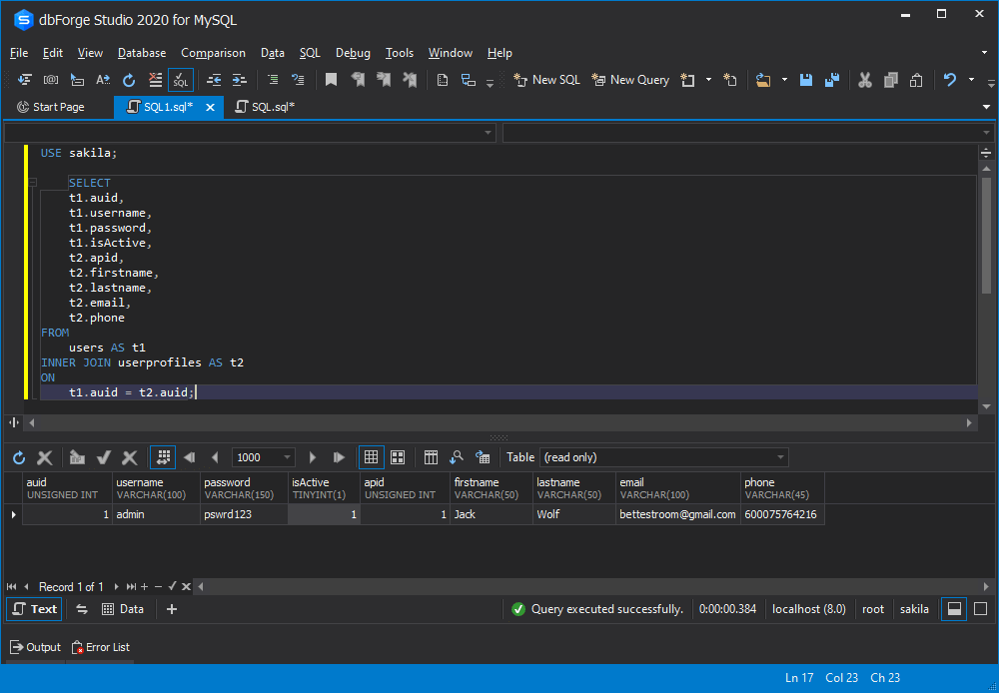

## 2. MySQL OUTER JOINs

In contrast to INNER JOINs, OUTER JOINs return not only matching rows but non-matching ones as well. In case there are non-matching rows in a joined table, the NULL values will be shown for them.

There are the following two types of OUTER JOIN in MySQL: MySQL LEFT JOIN and MySQL RIGHT JOIN. Let’s take a closer look at each of them.

## 2.1 MySQL LEFT JOIN clause

LEFT JOINs allow retrieving all records from Table A, along with those records from Table B for which the join condition is met. For the records from Table A that do not match the condition, the NULL values are displayed.

To get a better understanding of LEFT JOINs, study a Venn diagram below.



Here is the syntax for MySQL LEFT JOIN:

SELECT columns

FROM tableA

LEFT [OUTER] JOIN tableB

ON tableA.column = tableB.column;

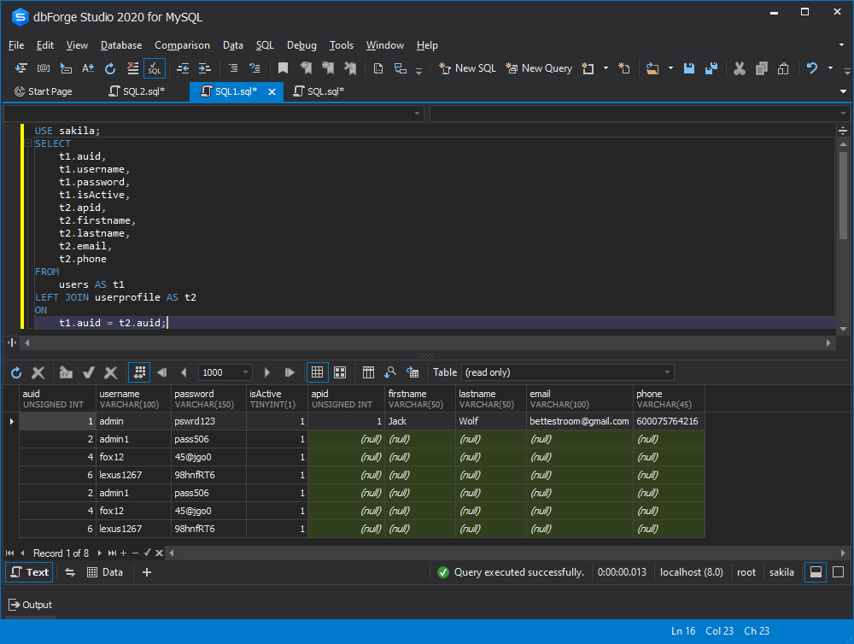

## 2.2 MySQL RIGHT JOIN clause

Accordingly, RIGHT JOINs allow retrieving all records from Table B, along with those records from Table A for which the join condition is met. For the records from Table B that do not match the condition, the NULL values are displayed.

Below is a Venn diagram for you to gain a deeper insight into RIGHT JOINs.



Here is the syntax for MySQL RIGHT JOIN:

SELECT columns

FROM tableA

RIGHT [OUTER] JOIN tableB

ON tableA.column = tableB.column;

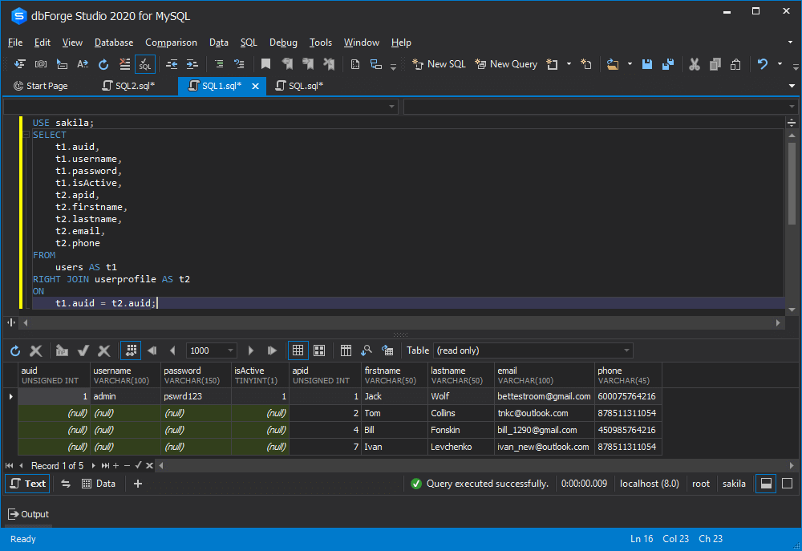

## 3. MySQL CROSS JOIN clause

MySQL CROSS JOIN, also known as a cartesian join, retrieves all combinations of rows from each table. In this type of JOIN, the result set is returned by multiplying each row of table A with all rows in table B if no additional condition is introduced.

To better understand CROSS JOINs, study a Venn diagram below.

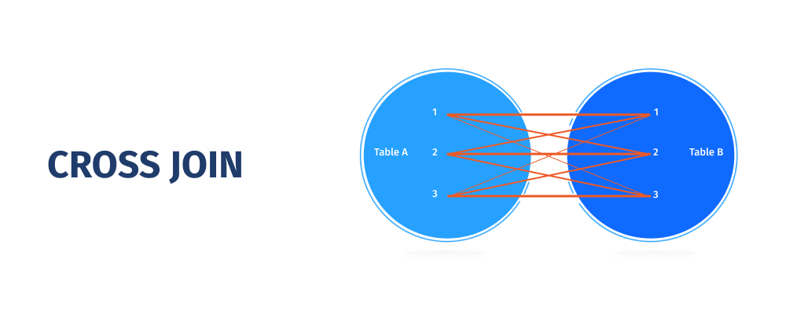

When you might need that type of JOIN? Envision that you have to find all combinations of a product and a color. In that case, a CROSS JOIN would be highly advantageous.

Here is the syntax for MySQL CROSS JOIN:

SELECT columns

FROM tableA

CROSS JOIN tableB;

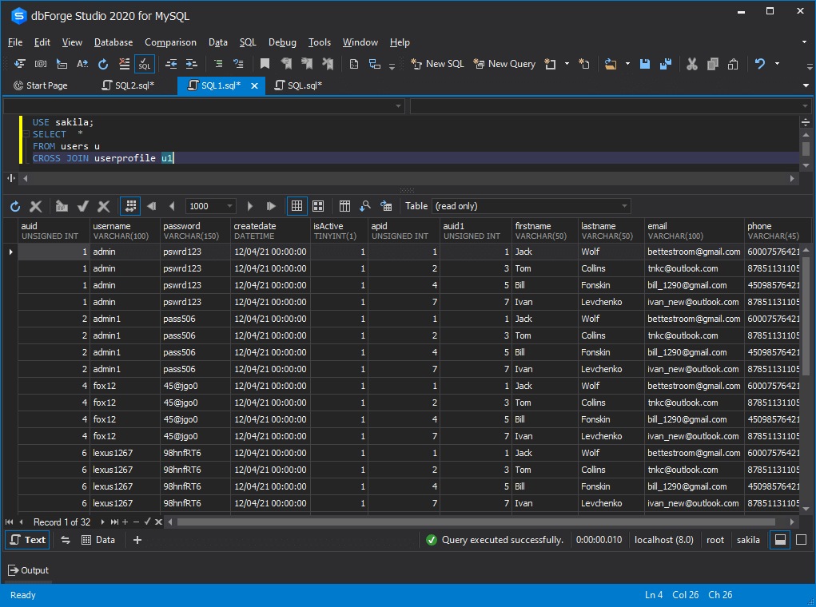

## MySQL JOINs guidelines

JOINs in MySQL allow you to use a single JOIN query instead of running multiple simple queries. Thus, you can achieve better performance, reduce server overhead, and decrease the number of data transfers between MySQL and your application.

Unlike SQL Server, MySQL does not support FULL OUTER JOIN as a separate JOIN type. However, to get the results same to FULL OUTER JOIN, you can combine LEFT OUTER JOIN and RIGHT OUTER JOIN.

SELECT * FROM tableA

LEFT JOIN tableB ON tableA.id = tableB.id

UNION

SELECT * FROM tableA

RIGHT JOIN tableB ON tableA.id = tableB.id

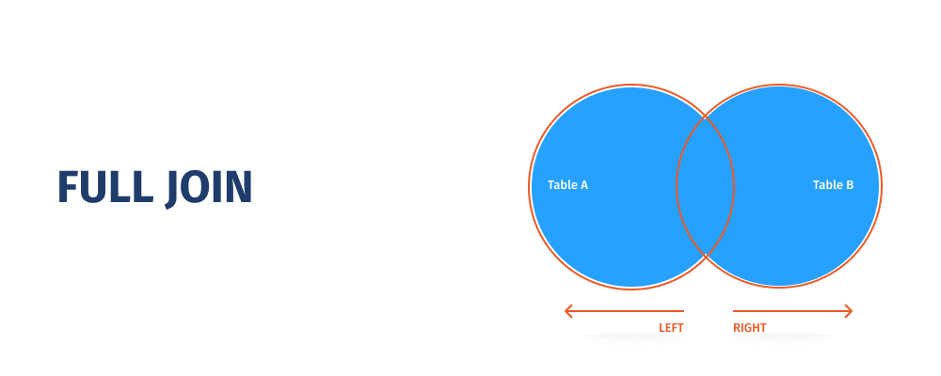

Using MySQL JOINs, you can also join more than two tables.

SELECT *

FROM tableA

LEFT JOIN tableB

ON tableA.id = tableB.id

LEFT JOIN tableC

ON tableC.id = tableA.id;